Proposed Deep Learning Solution
We propose a multilingual (English/Hindi) Ayurvedic chatbot built on transformer-based deep learning. The core pipeline follows a retrieval-augmented generation (RAG) approach: user text (in English or Hindi) is first normalized and translated into English, relevant Ayurvedic knowledge is retrieved, and a neural language model generates the answer, which is then re-translated to the user’s language if needed. For example, the AyurSanvaad system auto-detects any of 22 Indian languages, translates queries to English, retrieves answers from a curated Ayurveda knowledge base, and finally translates the response back[1]. In our design, Hindi inputs would likewise be translated to English (using a model like IndicTrans2 or Google Translate), processed by the core English-language model, and the output translated back to Hindi. This leverages large pre-trained English models (e.g. transformer-based encoders/decoders) while still serving Hindi users. We will fine-tune the model on domain data (Ayurvedic texts and FAQs) to capture specialized terminology. Optionally, separate modules (or the model itself) can perform intent classification and entity extraction (e.g. symptom names) before generation.
The high-level model architecture is a transformer-based encoder–decoder (or encoder-only with a separate decoder layer) suited for sequence-to-sequence tasks[2][3]. Concretely, the pipeline will include word embeddings and positional encodings to convert input tokens into vectors, followed by stacked transformer layers with multi-head self-attention and feed-forward sublayers[3]. The encoder processes the English-form query (after translation if needed), generating context-aware embeddings; a decoder or feed-forward head then produces the output text token by token. The self-attention mechanism allows the model to capture long-range dependencies and handle complex grammar, which is crucial for medical text[2]. For the domain knowledge, we incorporate a retrieval module: we embed user queries (with a model like all-MiniLM or a fine-tuned SentenceTransformer) and use a vector database (e.g. FAISS) to fetch the most relevant Ayurveda passages[4]. These retrieved passages are appended as extra context to the model input (“grounding” the generation), as in RAG pipelines[4][1]. The final response is then generated by the transformer (e.g. a fine-tuned GPT or encoder–decoder model like T5), which ensures fluent, contextually relevant answers in English; if the user’s original query was Hindi, we translate this output back to Hindi for the user. Overall, the system implements the standard conversational AI modules: NLU (understanding and embedding the input), a Dialogue Manager (which may handle retrieval and context management), and NLG (the transformer text generator)[5].
Example: A user asks in Hindi about “घुटने का दर्द” (knee pain). The system first translates this to English (“knee pain”), encodes it via transformer embeddings, retrieves matching Ayurvedic remedies from a knowledge base, and then generates an answer like “In Ayurveda, knee pain can be treated with XYZ herbs…” in English. Finally it translates the response back to Hindi. This pipeline mirrors the approach of recent multilingual medical bots[1][2].

Model Architecture (High-Level)
- Transformer Backbone: We use a transformer model (encoder–decoder or encoder with autoregressive decoder) as the core. Input tokens (from English or translated Hindi) are embedded with positional encodings[3]. Multiple self-attention layers allow the model to learn contextual representations of the entire input sequence in parallel[3]. This is ideal for handling complex medical language and multiple languages[2].
- Multilingual Handling: To support English and Hindi, we either fine-tune a multilingual transformer (e.g. mT5 or mBERT+decoder) or perform translation. In practice, we auto-detect language and translate Hindi to English before encoding[1]. The English-based model then generates the answer, which we translate back if needed. This strategy (used in AyurSanvaad) simplifies training by keeping a single English model, yet provides true multilingual interaction[1].
- Knowledge Integration (RAG): We incorporate an external Ayurvedic knowledge base. The input (in English) is embedded (e.g. with a SentenceTransformer) and matched against the KB using vector search (FAISS/Chroma) to retrieve the top-K relevant passages[4]. These passages are concatenated with the query and fed into the transformer, so that the generated answer is grounded in factual Ayurvedic content[4]. This reduces hallucination and ensures medical accuracy, following the RAG framework[4][1].
- Dialogue Manager: A lightweight manager handles session context and may decompose the query into sub-tasks (e.g. intent classification, entity extraction, then answer generation). For example, we could use separate classifiers (fine-tuned transformers) to identify symptoms or intent, whose outputs guide retrieval or generation. These would use standard classification heads on top of the transformer embeddings (again using cross-entropy loss).
This modular architecture (NLU → Retriever/DM → NLG) is standard for chatbots[5], ensuring maintainability and scalability.

Loss Function and Optimizer Selection
For training the deep model, we use standard sequence modeling losses and optimizers. The loss function will be cross-entropy between the predicted token distribution and the ground-truth tokens (sparse categorical cross-entropy when using integer token IDs). Padding tokens are masked out in the loss. This is exactly the approach in transformer-based chatbots[6]. If we include auxiliary tasks (e.g. intent classification), those branches also use categorical cross-entropy. If using multi-task learning, we simply add the losses (or weight them) as needed.
For optimization, Adam is a strong default: it adapts learning rates and converges well for transformers. In fact, the TensorFlow Transformer tutorial uses tf.keras.optimizers.Adam(…) with beta1=0.9, beta2=0.98, epsilon=1e-9[7]. We will similarly use Adam or AdamW (with weight decay) and a learning-rate scheduler (e.g. inverse-square-root warmup) to train the model. These choices have been shown to yield stable training for transformer language models[7]. (Alternatively, for classification heads one might use Adagrad or SGD, but Adam usually works best.) In summary: Sparse Categorical Cross-Entropy for language generation, Categorical Cross-Entropy for any classification tasks, and Adam(β1=0.9, β2=0.98) as optimizer with learning-rate scheduling[6][7].

System Architecture Diagram
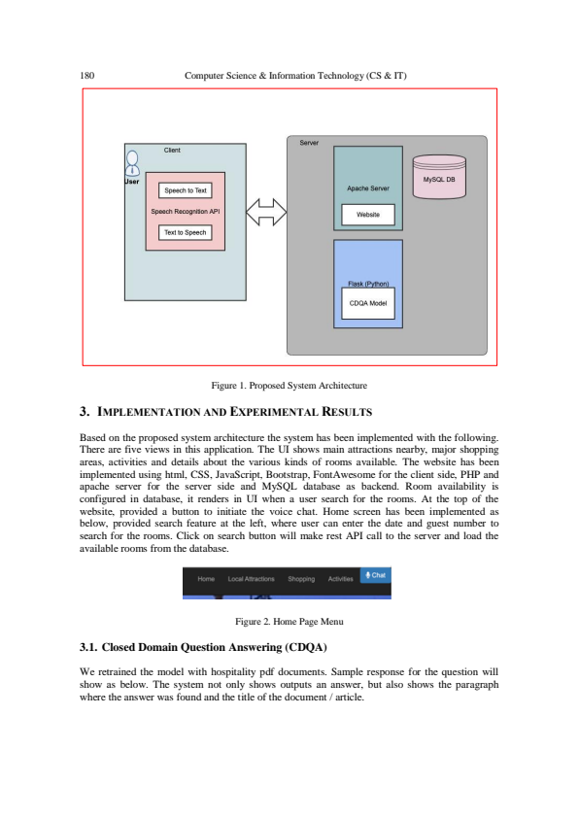
Figure: Example system architecture for the Ayurvedic chatbot. The user’s web interface (client) sends queries (English/Hindi) to the back-end. The back-end contains the dialogue manager and the deep-learning modules: a transformer model for NLU/NLG and a vector database (knowledge base) for Ayurvedic content. The model server handles translation, retrieval, generation, and returns the answer to the client.
In this architecture, the client (e.g. a web UI) communicates with a chatbot server. The server has: (1) a language-detection/translation API; (2) the deep learning model (running on TensorFlow or PyTorch, served via an API); (3) the Ayurvedic knowledge-base (searchable via FAISS or ElasticSearch). Upon receiving a message, the server processes it with the NLU module, retrieves relevant knowledge, generates a response with the transformer model, and sends it back. This follows the classic chatbot layout of NLU ➔ DM ➔ NLG[5], ensuring each component can be scaled independently (e.g. the model can run on GPU).
Overall, this design – combining multilingual translation, retrieval, and transformer generation – will produce a robust, accurate Ayurvedic chatbot. It aligns with recent research that shows transformer-based, multilingual architectures excel at healthcare chatbots[2][4]. The optimizer/loss choices and modular setup lay a solid foundation for future implementation and training of the working chatbot.
Sources: The design above draws on recent studies of multilingual medical chatbots and transformer architectures[1][4][2][3][6][7][5]. These references describe similar RAG pipelines, the use of transformers for multi-language NLP, and common loss/optimizer practices.

[1] [4] AyurSanvaad: A Multilingual Chatbot for Ayurvedic consultation using LLMs
https://www.atlantis-press.com/article/126015230.pdf
[2] [3] Multilingual Virtual Healthcare Assistant - PMC
https://pmc.ncbi.nlm.nih.gov/articles/PMC12371714/
[5] (PDF) Chatbot System Architecture
https://www.researchgate.net/publication/357925267_Chatbot_System_Architecture
[6] [7] A Transformer Chatbot Tutorial with TensorFlow 2.0 — The TensorFlow Blog
https://blog.tensorflow.org/2019/05/transformer-chatbot-tutorial-with-tensorflow-2.html

